**Low Level Design**

**Bike sale**

**1. Introduction**

1.1 What is low level documents?.................................3

1.2 Scope…………………………………………………………………….3

**2. Architecture**………………………………………………………..4

**3. Architecture Description**…………………………………..5-7

3.1 Gateway

3.2 Repository

3.3 power BI architecture

3.4 Power Bi Report server

**4. Unit test case**…………………………………………………………..8

**Introduction**

1.1 What is low level documents?

The goal of the LDD or Low-level design document (LLDD) is to give the internal logic design of the actual program code for the House Price Prediction dashboard. LDD describes the class diagrams with the methods and relations between classes and programs specs. It describes the modules so that the programmer can directly code the program from the document

1.2 Scope

Low-level design (LLD) is a component-level design process that follows a step-by-step refinement process. The process can be used for designing data structures, required software architecture, source code and ultimately, performance algorithms. Overall, the data organization may be defined during requirement analysis and then refined during data design work.

**2. Architecture**

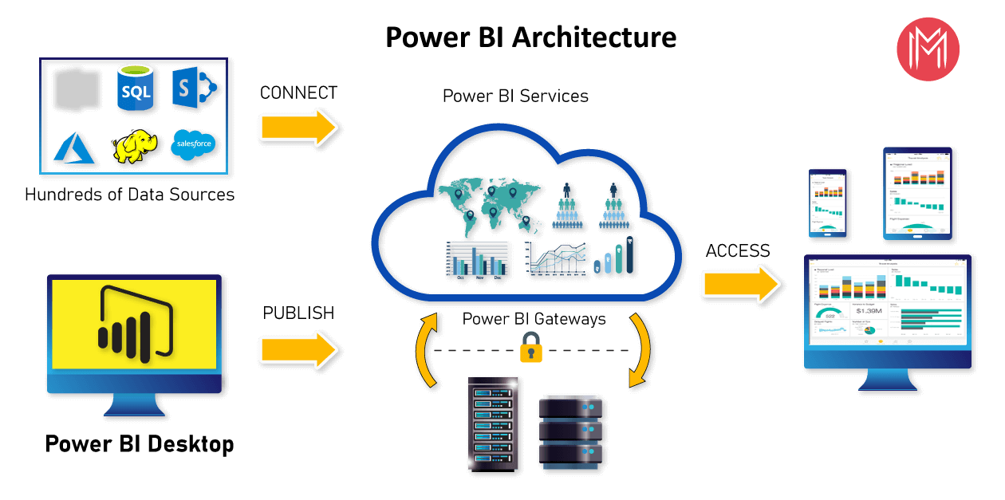

**Power BI Server Architecture**

Power BI architecture is a service built on top of Azure. There are multiple data sources that Power BI can connect to. Power BI Desktop allows you to create reports and data visualizations on the dataset. Power BI gateway is connected to on-premise data sources to get continuous data for reporting and analytics. Power BI services refer to the cloud services that are used to publish Power BI reports and data visualizations. Using Power BI mobile apps, you can stay connected to their data from anywhere. Power BI apps are available for Windows, iOS, and Android platforms.

**Architecture description**

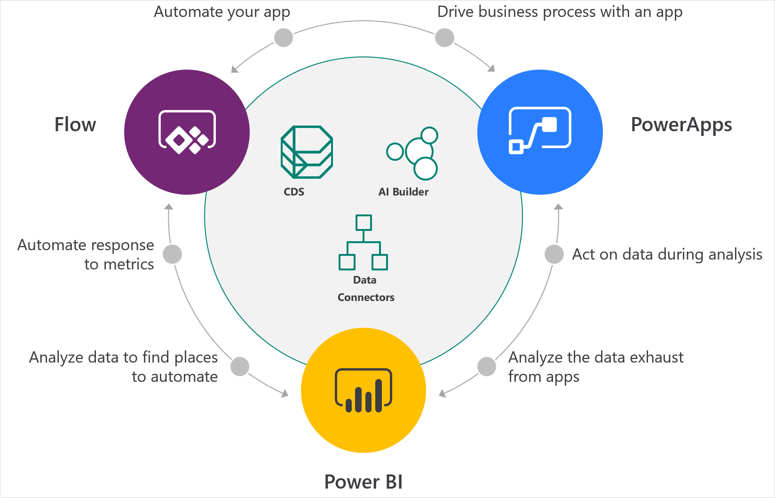

**Gateway**

It acts as an Entry gate to the Power BI Server and also balances the load to the Server if multiple Processes are configured.

Load balancer

Power BI Premium, with Power BI Report Server, has you covered with a complete solution. Power BI Premium provides dedicated capacity in the cloud and enhanced performance—without requiring per-user licenses for those consuming reports. And, it includes Power BI Report Server for on-premises reporting.

**Repository:-**

Power BI Server Repository is a PostgreSQL database that stores server data. This data includes information about Power BI Server users, groups and group assignments, permissions, projects, data sources, and extract metadata and refresh information

**Power BI Architecture**

*Power BI is a business suite that includes several technologies that work together.* To deliver outstanding business intelligence solutions, Microsoft Power BI technology consists of a group of components such as:

* Power Query (for data mash-up and transformation)
* Power BI Desktop (a companion development tool)
* Power BI Mobile (for Android, iOS, Windows phones)
* Power Pivot (for in-memory tabular data modeling)
* Power View (for viewing data visualizations)
* Power Map (for visualizing 3D geo-spatial data)
* Power Q&A (for natural language Q&A)

1. Data Sources

An important component of Power BI is its vast range of data sources. You can import data from files in your system, cloud-based online data sources or connect directly to live connections. If you import from data on-premise or online services there is a limit of 1 GB. Some commonly used data sources in Power BI are:

Excel

Text/CSV

XML

JSON

Oracle Database

IBM DB2 Database

MySQL Database

PostgreSQL Database

Sybase Database

Teradata Database

SAP HANA Database

SAP Business Warehouse server

Amazon Redshift

Impala

Google BigQuery (Beta)

Azure SQL Database

Salesforce Reports

Google Analytics

Facebook

GitHub

**Power BI Report Server**

The Power BI Report Server is similar to the Power BI Service. The only difference between these two is that Power BI Report Server is an on-premise platform. It is used by organizations who do not want to publish their reports on the cloud and are concerned about the security of their data.

Power BI Report Server enables you to create dashboards and share your reports with other users following proper security protocols. To use this service, you need to have a Power BI Premium license.

Power BI Gateway

This component is used to connect and access on-premise data in secured networks. Power BI Gateways are generally used in organizations where data is kept in security and watch. Gateways help to extract out such data through secure channels to Power BI platforms for analysis and reporting

**Unit Test Case**

|  |  |
| --- | --- |
| Bikes |  |
| Mountain Bikes | In this showroom, most selling bikes is a mountain bike. In my analysis, this showroom is located in the mountain area. |
| Road Bike | The second number of selling is a road bike in this showroom |
| Touring Bike | The lowest selling bike is the touring bike because manly people do not prefer bikes for touring. |

|  |  |
| --- | --- |
| Accessories |  |
| Tires and Tubes | Highest amount of sell |
| Bottle | 2nd |
| Bike racks | 3rd |
| Bike stands | 4th |
| cleaner | 5th |

**Consultation**

I have seen in this data. After October sales are increase and starting of year sales are decreasing.